|  |  |
| --- | --- |
| **Project Title** | **Application Integration - API** |
| **Qualification Name (NICF)** |  |
| **Product Name** |  |
| **Module Name (NICF)** | **Application Integration (API using Spring Boot & React JS)** |

|  |  |  |  |
| --- | --- | --- | --- |
| **Student name** | | **Assessor name** | |
|  | |  | |
| **Date issued** | **Completion date** | | **Submitted on** |
|  |  | |  |
|  | |  | |
| **Project title** | **Application Integration - API** | | |

|  |
| --- |
| **Learner declaration** |
| I certify that the work submitted for this assignment is my own and research sources are fully acknowledged.  Student signature: Date: |

1. Project Background

The Know-Your-Neighborhood application was developed using Spring Boot..

1. Project Objective

•

Tools and Platform

1. Project Requirement Specification

The application can use existing APIs to log in and retrieve basic information such as name and email from the API. Users can also register/login manually or via social login (Google / Facebook).

The Know Your Neighborhood website consists of the following main pages:

1. Home Page
2. Registration Page
3. Login Pages with API link
4. Contact us Page
5. About us Page
6. Terms and Conditions Page
7. Task 1

**APIs and Type of APIs**

1. Explain what API is, its role and need for API and research existing APIs.
2. Examine the relationship between API and SDK.
3. Identify types of API and its uses.
4. Identify the potential security issues with API and critically evaluate the suitable API for given scenario or your selected application.

**Solution:**

1. **Explain what API is, its role and need for API and research existing APIs.**
2. What is API?
3. Its Role
4. Need for API

* Improved collaboration:

1. Example APIs for mobile, desktop, Web APIs.
2. **Examine the relationship between API and SDK.**
3. **Identify types of API and its uses.**
4. Examine different APIs
5. Examine the uses of APIs for a particular type
6. **Identify the potential security issues with API and critically evaluate the suitable API for given scenario or your selected application.**
7. Identify potential security issues with API

* Injection Attack
* DDoS Attacks
* Broken Authentication
* Sensitive Data Exposure
* Broken Access Control
* Parameter Tampering
* Man-In-The-Middle-Attack (MITM)

1. Evaluate potential security issues in a suitable API of Know-Your-Neighborhood

* **Injection:**
* **Broken User authentication:**
* **Broken access control/authorization**
* Suitable API for given scenario

1. Task 2

**Apply the knowledge of API research to design an application.**

1) Analyze the given scenario, identify the requirements and select the appropriate API.

2) Develop relevant wireframes for using the API for specific purposes.

3) Identify your scope and target platform.

4) Evaluate and justify your choice of APIs for your application. (Shows security for the selected API.)

**Solution:**

1. **Analyze the given scenario, identify the requirements, and select the suitable API for the same.**
2. Identify what are the requirements in “Know-Your-Neighborhood” project.
3. Select a suitable login API among 3 different login APIs in research in the project scenario.

* Facebook Login API
* Google OAuth2
* LinkedIn

**Suitable Login API for KYN**

|  |  |
| --- | --- |
|  |  |
|  |  |

**Why Choose the API?**

1. **Develop the relevant wireframes to utilize the API for given purpose.**
2. Register Page showing Google Register Button and Form Input Register Wireframe

After user signing using google account with default scope, KYN website can access some user information like user’s google/facebook ID, name, and profile URL. With this information KYN website access the user to sign in to the website.

1. Login Page showing Google and Facebook Button and Form Input Login Wireframe

The step is same like sign up function user only click google button

User will see pop up to choose their google account

After choose the account user will go to Dashboard page

1. Your KYN dashboard Wireframe after Google or Facebook login API

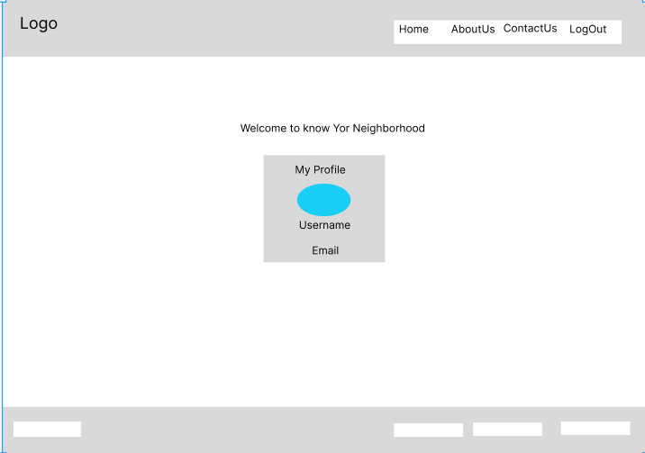

1. **Identify the scope and target platforms.**

Google and Facebook's APIs use different languages ​​to build applications, so these two APIs are now available on most devices and run on most operating systems. For example, these APIs can be used in Windows and Mac environments as well as desktop and mobile devices.

1. **Evaluate and justify the selection of chosen APIs for the application. (Show security of selected APIs.)**

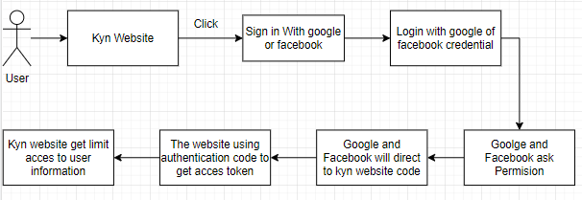

The situation is that the user needs to login/register on the KYN website. First, user clicks login/register with google or Facebook button. then user will be directed to google.com or facebook.com where login status check is done.

**Security of selected API for the application**

**Server-side authentication**

We may use server-side authentication if we need to access and keep sensitive user data or functionality. Server-side authentication, commonly known as OAuth authorization token flow, is designed for use by programs running on a web server. Google offers this option for the majority of use cases as it is the most secure way to implement OAuth.

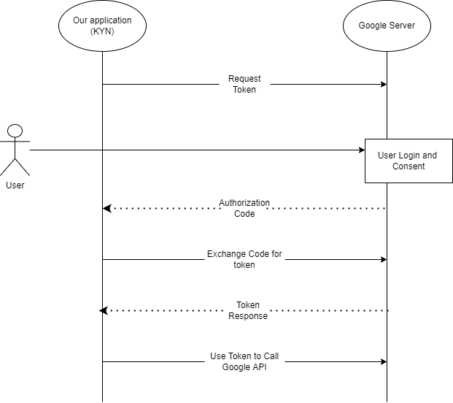

**Client-side authentication**

1. Task 3

**Application Implementation**

1. Introduce three different types of backend, frontend, and API implementation process
2. Discuss a range of suitable development environments for front-end and back-end to develop an application
3. Develop a backend and Web service using selected development environment for given scenario
4. Develop an application that utilizes an API.
5. Construct the application which implements the selected API in Task 2.

**Solution:**

1. **Introduce three different types of backend, frontend, and API implementation process**
2. Three different types of Backend

* Express JS
* Spring Boot
* Laravel
* php

1. Three different of frontend

* React JS
* Angular JS
* Vue JS

1. Three different of API

* REST API
* SOAP API
* RPC API

1. **Discuss a range of suitable development environments for front-end and back-end to develop an application**

1. **Develop a backend and Web service using selected development environment for given scenario**

**Screen Capture of KYN Website Back-End**

1. **Back-end google login**

1. **Back-end Facebook login**
2. **Back-end local login/register**
3. **Develop an application that utilizes an API.**
4. **Develop front-end using react**

* **Index.js**
* **Login page**

**Login.jsx**

* **Register page**

**Register.jsx**

* **OnlineService.js**
* **Oauth2RedirectHandler**

1. **Construct the application which implements the selected API in Task 2.**
2. **How to Login/Register with Google API**

* Go to the Google API and then click console
* And Api&Services
* Click Create Project
* Fill the name project and click create and you project will created
* Click “Create Credential” and Choose Oauth client ID then click Configure Consent Screen
* Choose “External” then click create
* Fill the form then click save and continue until the end
* click “Create Credential” and Choose Oauth client ID again
* Choose web application, in application type
* Add project URL and the click create
* Copy then paste to the application yml in spring

1. **How to Login/Register with Facebook API**
   * Firstly, open meta for developer in google then login into your account
   * create an app by clicking “create app” below
   * For type select none then fill the details accordingly to the project
   * Then enter your password
   * Go to setting – basic then copy and paste “App ID” and “App Secret” to the code editor in Application.yml file
2. Task 4

**Create the following items under “Application Testing” in Project Report**

1. Implement white Box testing for the developed API of your Application
2. Conduct Black Box testing (UAT testing) of your developed application and show the evidence for each test case.
3. Once the testing done check failed test cases and the reason to fail the same and implement your application accordingly.

**Solution:**

1. **Implement white Box testing for the developed API of you Application**

* What is white Box testing?
* Why we using white box testing?

White box testing is used to:

• Ensure that each independent path within a module is executed at least once.

• Discover logic or design errors that may occur during the actual implementation.

• Identify security holes or vulnerabilities in your code.

• Check for typos and grammatical errors.

* Test all controller mappings using POSTMAN tool and then record your result
* Using Facebook

1. **Conduct Black Box testing (UAT testing) of your developed application and show the evidence for each test case.**

* What is black box testing?
* Benefit black box testing?
* UAT testing

|  |  |  |  |  |  |  |  |  |
| --- | --- | --- | --- | --- | --- | --- | --- | --- |
| Test case | Scenario | Preconditions | Execution steps | Test Data | Expected Result | Actual Result | Pass/Fail | Reference Evidence |
| TC01 | Ensure that users can register on the KYN website | the website has been designed and developed | 1. Go to KYN Website 2. Go to login oage 3. Click on the register button 4. Fill in all input data 5. Click on Register button | Username: arya  Email: ekabudhiartatessting@gmail.com  Password: 789 | The user's new information will be saved into the database and the user will be forwarded to the login page. | As expected, | PASS | RE01 |

1. Task 5

**Create the following items under “Review and Reflect on the APIs Used” in Project Report**

1. Review your developed API, identify the strength and weaknesses of API.
2. Provide data security report of your developed application.

**Solution:**

1. **Review your developed API, identify the strength and weaknesses of API.**

* The application development process
* Strengths and Weakness selected API, features

1. **Provide data security report of your developed application.**

The backend KYN app is secured by Spring Security. Spring Security offers smart and scalable security features such as authentication and authorization.

**Authentication with JWT**

**Security with OAuth**

1. Task 6